What is Business Intelligence Environment?
- A Business Intelligence Environment refers to the high-level architecture required to implement and run a Business Intelligence (BI) program.
- It enables the flow of large amounts of data from different sources into a central repository such as a data warehouse.
- The processed and structured data is then delivered to data marts and analytical tools for analysis and reporting.
- This environment includes components such as data sources, staging areas, data warehouses, data marts, and analytical tools, which help organizations convert raw data into useful information for better decision making.
What is a Staging Area?
A Staging Area is a temporary storage location where data from different sources is collected, cleaned, transformed, and integrated before being loaded into the data warehouse. It helps ensure that the data is accurate, consistent, and properly formatted before analysis.
What is a Data Warehouse?
A Data Warehouse is a centralized repository that stores large volumes of integrated data collected from multiple sources within an organization. The data is organized and structured in a way that supports analysis, reporting, and decision making. It allows businesses to analyze historical data and identify trends for strategic planning.
What is a Data Mart?
A Data Mart is a smaller, subject-oriented subset of a data warehouse designed for a specific department or business area. It contains focused data related to functions such as sales, marketing, or finance, making it easier and faster for users to perform analysis and generate reports.

Explain the Process of Designing a Business Intelligence (BI) Program
Designing a BI program is the process of understanding the business requirements, determining the analytical applications needed to support those requirements, identifying the subject areas around which the analysis revolves, designing a subject-oriented information framework, determining the information required, integrating data from different sources, and mapping these requirements onto a general BI architecture.
The process involves the following steps:

1. Understanding Business Requirements
The first step is to understand the business goals and decision-making needs of the organization. This helps identify what problems BI should solve.
Example:
A retail company may want to:
- improve sales forecasting
- optimize inventory levels
- personalize marketing strategies

2. Determining Analytical Applications
Next, organizations determine the analytical applications required to support business requirements.
Example:
A retail company may implement:
- a sales forecasting model
- an inventory optimization system
- a customer segmentation tool
These applications help analyze data and improve decision making.

3. Determining Subject Areas
Subject areas represent the main business domains around which analysis is performed.
Common subject areas include:
- Sales
- Inventory
- Customers
- Marketing
For example, in a retail company these subject areas help analyze product demand and customer behavior.

4. Designing a Subject-Oriented Information Framework
In this step, organizations define the key metrics or performance indicators that will be analyzed.
Example (Sales subject area):
- Total revenue
- Units sold
- Sales by product category
- Average transaction value
These metrics help measure business performance.

5. Determining the Information Needed
After defining the metrics, the organization determines the data required to calculate those metrics.
Example:
A retail company may require:
- transaction records
- product details
- customer information
- historical sales data
This information forms the basis for analysis.

6. Data Integration
Data from different sources must be collected, cleaned, transformed, and integrated before analysis.
Example:
Data may come from:
- POS (Point of Sale) systems
- inventory management systems
- customer databases
- online sales platforms
This ensures that data is accurate and consistent.

7. Mapping to BI Architecture
Finally, the requirements are mapped into a BI architecture, which organizes data storage and analysis. The BI architecture supports the flow of data from various sources to analytical tools.
Typical BI architecture includes:
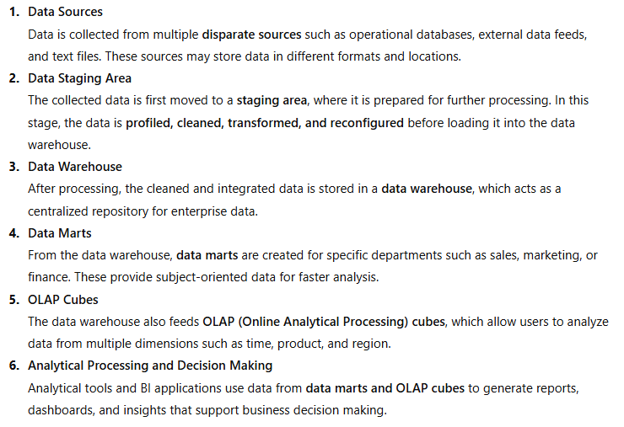
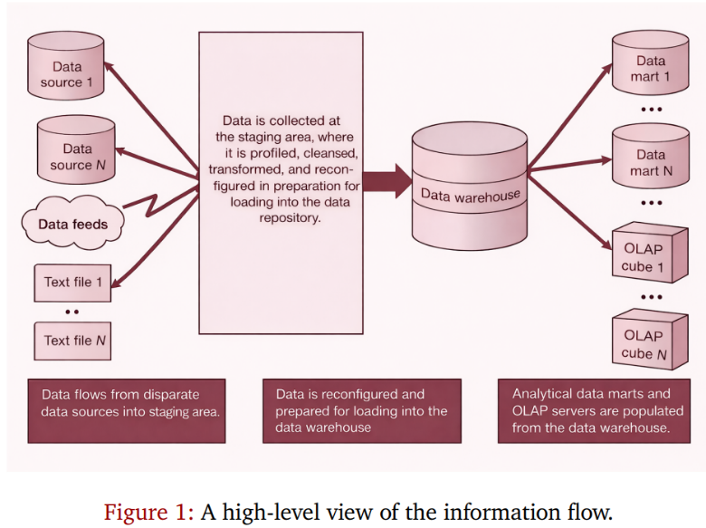
Data Sources
↓
Staging Area
↓
Data Warehouse
↓
Data Marts
↓
Analytical Tools / Dashboards

In this architecture, data from different sources is first collected in the staging area, where it is cleaned and transformed. The processed data is stored in a data warehouse, which acts as a central repository. From the data warehouse, data marts are created for specific departments such as sales or marketing. Finally, analytical tools and dashboards are used to generate reports and support business decision making.
Example:
A retail company stores integrated data in a data warehouse, creates data marts for sales and marketing, and uses tools like Power BI or Tableau to analyze trends and improve business performance.

Conclusion
By following these steps, organizations can design an effective BI program that integrates data from multiple sources and converts it into meaningful insights, enabling better and faster business decisions.

Business Case for Business Intelligence
A business case for Business Intelligence (BI) explains why an organization should implement a BI program and how it will benefit the business.
- Planning the implementation of a BI program requires understanding the high-level building blocks and components involved in the BI environment.
- Without a clear roadmap of the required components and processes, the BI project may fail.
By analyzing business data such as sales, inventory, and customer information, BI enables companies to identify trends, improve operations, and gain competitive advantages.

For example, in a retail organization, BI can analyze sales, inventory, and customer data to improve business performance.
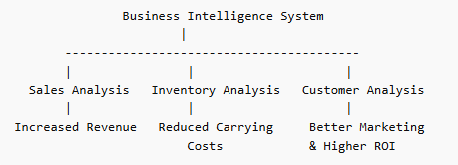
Through sales analysis, BI tools examine sales data to identify trends, popular products, and customer buying patterns. This helps organizations improve sales strategies and increase revenue.
Through inventory analysis, BI monitors stock levels and demand patterns. This helps businesses manage inventory efficiently and reduce carrying costs such as storage and handling expenses.
Similarly, BI can also help organizations consolidate customer data and improve marketing campaigns, leading to higher customer engagement and improved return on investment (ROI).

Business Intelligence Process
The Business Intelligence (BI) process is the sequence of activities used to convert raw business data into actionable knowledge that supports decision making. It involves understanding business processes, collecting and integrating data, applying business rules, and analyzing information to generate insights.

1. Business Process Modeling and Analytic Needs Assessment
This step focuses on understanding how the business operates and what information is required for analysis. It involves studying how information flows within business processes.
Organizations examine the journey of products or services through different stages, such as procurement, manufacturing, inventory management, and distribution. By understanding these processes, analysts can identify the metrics and data needed for business analysis.
Example:
In a retail company, analysts study how products move from suppliers to warehouses and finally to customers. Understanding this process helps identify information such as stock levels, sales performance, and delivery times.

2. Information Repository Management
The core component of a BI system is the centralized enterprise data repository, usually a data warehouse.
A data warehouse collects and integrates data from multiple sources across the organization and stores it in a structured format suitable for analysis. This centralized repository allows analysts to access reliable data for reporting and decision making.
Example:
A retail company may collect data from sales systems, customer databases, and inventory systems and store it in a data warehouse for analysis.

3. Business Rules
Business rules define the logic and conditions that guide business operations and analysis. These rules may be set by internal policies, industry standards, or regulatory requirements.
Business rules help ensure that data is interpreted correctly and that analytical results follow the organization’s operational guidelines.
Example:
- An online store may apply a discount automatically for orders above $100.
- A hotel booking system may require a non-refundable deposit for reservations made within 24 hours of check-in.
These rules help define how transactions and decisions should be processed.

4. Information Integration
Information integration involves collecting and combining data from different sources to populate the data warehouse.
Since organizations store data in multiple systems, this step ensures that data is cleaned, standardized, and integrated before analysis.
Key activities include:
- Data profiling: understanding the structure and characteristics of the data.
- Data quality and validation: cleaning and verifying the accuracy of data.
- Data transformation: converting data into a consistent format suitable for integration.
Example:
A company may combine customer information, sales data, product data, and external demographic data to support customer relationship management (CRM) analysis.

5. Knowledge Creation
The final step of the BI process is knowledge creation, where analysts examine processed data to discover patterns, trends, and insights.
This analysis transforms data into actionable knowledge, which helps managers make strategic decisions.
Knowledge creation can occur in two ways:
- Directed analysis: using specific analytical tools and models.
- Automated discovery: using data mining and machine learning techniques.
Example:
By analyzing customer purchase data, a company may discover that customers who buy smartphones often purchase accessories, allowing the company to create targeted marketing campaigns.

Conclusion
The Business Intelligence process integrates business understanding, data management, and analytical techniques to transform raw data into actionable insights. This process enables organizations to make informed decisions, improve operational efficiency, and gain competitive advantages.

System Infrastructure in a Business Intelligence Environment
A Business Intelligence (BI) system infrastructure provides the technological foundation required to collect, store, process, and analyze organizational data. A BI program typically requires three logical system platforms that support different stages of data processing and analysis.
These platforms include:
- Data Staging Area
- Data Warehouse
- Analytical Environment
Although there may be only one staging area and one data warehouse, there can be multiple analytical systems depending on the number of users and analytical applications.

1. Data Staging Area
The data staging area is the temporary location where data from multiple sources is collected and prepared before loading it into the data warehouse.
In this stage, data is:
- collected from different systems
- cleaned and transformed
- integrated into a consistent format
This ensures that the data is accurate and ready for storage in the data warehouse.

2. Data Warehouse
A data warehouse is a centralized repository that stores integrated enterprise data from multiple sources. The data stored in the warehouse is non-volatile, meaning it remains stable and is mainly used for analysis rather than daily transaction processing.
The data warehouse allows organizations to:
- store large volumes of historical data
- perform complex queries
- support reporting and decision making

3. Analytical Environment
The analytical environment is the layer where users interact with the BI system. It consists of data marts, analytical tools, and user interfaces.
- Data marts are subject-oriented subsets of the data warehouse designed for specific departments such as sales or marketing.
- Analytical tools such as OLAP systems, dashboards, and reporting tools allow users to analyze the data and generate insights.
Components Supporting BI System Infrastructure
To support a Business Intelligence (BI) environment, several technological components are required. These components ensure that data can be stored, processed, analyzed, and delivered efficiently to users. The major components include hardware, relational database management systems, data storage management, application servers, and system/network management.

1. Hardware
Hardware provides the physical infrastructure required for BI operations. The hardware requirements vary depending on the activity performed in different parts of the BI system.
For example, the data staging area requires high connectivity bandwidth, large storage capacity, and high processing power to collect and integrate data from multiple sources before loading it into the data warehouse.
The data warehouse requires large storage capacity to maintain the data tables that store enterprise information.
If the data warehouse is accessed by many data clients and analytical applications simultaneously, the system must be designed to handle the required workload. The client base and system implementers must agree on the required performance levels, and the hardware must be sized accordingly.
The hardware requirements may also vary depending on the type of analytical system used. For example, an OLAP server may need additional storage and computational power because it stores data in multidimensional form and maintains aggregated summary data. It must also support multiple analysts performing interactive queries simultaneously.
On the other hand, some analytical platforms may simply provide a visual interface to query tools used for exploratory analysis, which may not require as much storage or computational power as OLAP systems.

2. Relational Database Management System (RDBMS)
A Relational Database Management System is used to manage the databases within the BI environment. It may serve as a temporary storage location in the staging area or as the main platform for storing data in the data warehouse.
RDBMS organizes data into related tables and enables efficient querying and data retrieval. The linkage between tables is maintained through the relational database framework.

3. Data Management / Storage Management
BI systems handle very large volumes of data. Therefore, an effective data storage management platform is required to support data storage and processing activities.
A separate data storage subsystem is often used to provide efficient storage and access to large datasets. Organizations typically use networked storage systems that allow data to be accessed from different locations while ensuring scalability and easy expansion.

4. Application Server
BI analytics often follow a three-tier architecture consisting of:
- Data server (data warehouse)
- Application server
- Client interface (user desktop)
The application server acts as the middle layer and performs computational processing for analytical applications. It interacts with the data warehouse and delivers processed information to users.
The size and number of application servers depend on the type of analytics being performed. Systems such as OLAP servers require higher computational power, while simpler query systems may only manage database connections and data streaming.

5. System and Network Management
System and network management ensure that the BI environment operates efficiently and reliably. Organizations must maintain agreed service levels for data delivery, system response time, and report generation.
Important management activities include:
- Performance management – monitoring system performance and identifying bottlenecks
- Capacity planning – determining the size and resources required for system components
- Backup and recovery management – protecting data and restoring it in case of data loss
- Configuration management – managing system layout, upgrades, and software versions
- Continuous monitoring – tracking system performance and generating alerts when issues occur

Information Access, Delivery, and Analysis in BI Environment
A Business Intelligence (BI) program can succeed only if users are able to easily and securely access the data required for analysis. Therefore, BI systems provide mechanisms for information access, delivery, and analysis so that decision makers can obtain insights from organizational data.
The major aspects include:
- Information Delivery
- Security
- Portal
- Visualization
- Query and Reporting
- Text Analysis

1. Information Delivery
Information delivery refers to the creation, management, and distribution of information across the organization.
It includes:
- Query and report management, which allows users to create and manage queries used for generating reports.
- Content management, which organizes report templates and supporting materials such as text, images, and documents.
- Document management, which provides a searchable repository for different types of documents such as text files, HTML pages, PDFs, and multimedia content.
BI systems also use publish/subscribe mechanisms that allow users to subscribe to reports or share their analytical results with others. These reports may be delivered through emails, alerts, or wireless notifications.
Information packaging ensures that reports are delivered in the most appropriate format for business users.
Example:
Results from financial analysis can be extracted from data mart queries and automatically delivered as spreadsheet reports to managers' desktops.

2. Security
Security is an important part of BI systems because many users access data remotely and some data may be sensitive.
A BI security framework ensures that only authorized users can access specific data.
Security mechanisms include:
- Firewalls to control network traffic
- Encryption of information on servers and client devices
- Intrusion protection systems that detect suspicious activities
- Access control policies that restrict access to specific tables, columns, or rows in the database
- Security policies for analytical tools and user interfaces
These measures protect business data from unauthorized access or misuse.

3. Portal
A BI portal is a web-based interface that allows users to access BI tools, reports, and dashboards from a single platform.
Portals allow users to customize their view of reports and data based on their role in the organization.
For example, an executive portal may display dashboards with key performance indicators (KPIs) such as revenue, sales growth, and market performance.

4. Visualization
Visualization refers to the graphical representation of data to make analysis easier and faster.
It helps users identify:
- patterns
- trends
- unusual data values (outliers)
Visualization may include charts, graphs, dashboards, and multidimensional views of data.
These tools help managers quickly understand business performance and make better decisions.

5. Query and Reporting
Query and reporting tools allow users to retrieve and analyze data from the BI system.
Different types of reporting include:
Standard reporting
Regular reports that show business performance such as profit and loss reports, budget reports, or production reports.
Structured queries
Predefined queries that retrieve specific information such as sales by region.
Ad hoc queries
Queries created by users themselves to analyze data in different ways.
Exception-based reporting
Reports that alert managers when unusual events occur, such as a sudden drop in sales.
These tools provide a visual interface that allows users to create queries and generate reports easily.

6. Text Analysis
Not all business data is structured. Some data exists in semi-structured or unstructured formats such as documents, emails, or resumes.
Text analysis tools analyze this type of data and extract useful information.
For example, text mining tools can scan resumes and identify skills, experience, and qualifications, converting this information into structured data for analysis.

Conclusion
Information access, delivery, and analysis components enable organizations to securely distribute information, analyze business data, and present insights effectively. These capabilities allow decision makers to easily access relevant information and make informed business decisions.

Services in a Business Intelligence Environment
While implementing a Business Intelligence (BI) program, organizations may not always have the required expertise internally. Building a BI infrastructure often requires specialized knowledge and technical skills that may only be needed during certain stages of the project.
Therefore, organizations often rely on external service providers to support the development, implementation, and management of BI systems.
The major services include:
- Architecture and Integration
- Migration
- Analytical Service Providers
- Training
- Strategic Management

1. Architecture and Integration
When building a data warehouse and BI architecture, organizations may require expert guidance to design the overall system.
External consultants who have worked on successful BI projects can help in:
- designing the BI architecture
- planning the data warehouse
- integrating data from different sources
Many ETL and data integration software providers also offer consulting services to help organizations build efficient data integration processes.
In some cases, service providers may even perform the integration themselves, where they import organizational data, process it according to integration rules, and return the transformed data.
The ultimate goal of this service is to ensure that the BI system satisfies business partners and meets organizational needs.

2. Migration
Some organizations may want to implement BI, but their existing data systems may not be suitable for integration.
This may happen because:
- the current systems are outdated
- the data is stored in legacy or proprietary systems
- the information is difficult to extract
In such cases, organizations may first need to migrate their data and systems to modern platforms before implementing BI.
Since data migration is usually a one-time process, organizations often hire external service providers to handle this task efficiently.

3. Analytical Service Providers
Sometimes the cost of building and maintaining a complete BI infrastructure may be too high for an organization.
In such situations, organizations can use analytical service providers.
These providers offer BI services such as:
- data cleansing
- data integration
- hosted data warehouses
- analytical tools and reporting services
This allows organizations to use BI capabilities without building their own infrastructure.

4. Training
For a BI program to succeed, employees must have the necessary knowledge and skills.
Therefore, organizations may use training services provided by specialized institutions such as the Data Warehousing Institute.
Training programs typically cover topics such as:
- data warehouse architecture
- data integration techniques
- data marts and operational data stores
- ETL tools and data transformation
- OLAP systems and analytical tools
Proper training ensures that employees can effectively use BI tools and technologies.

5. Strategic Management
Sometimes both the technical team and business users may not fully understand the analytical capabilities available in the market.
In such situations, organizations may consult industry experts or strategic advisors.
These consultants help organizations:
- understand BI opportunities in their industry
- select appropriate analytical applications
- align BI strategies with business goals
This ensures that the BI program supports long-term business strategy and decision making.

Conclusion
External services play an important role in supporting Business Intelligence programs. They help organizations design BI architecture, migrate legacy systems, provide analytical capabilities, train employees, and guide strategic decisions. These services ensure the successful implementation and effective use of BI systems.

The Business Case
A business case for Business Intelligence (BI) explains why an organization should implement a BI program and how it will benefit the business.
- Planning the implementation of a BI program requires understanding the high-level building blocks and components involved in the BI environment.
- Without a clear roadmap of the required components and processes, the BI project may fail.
By analyzing business data such as sales, inventory, and customer information, BI enables companies to identify trends, improve operations, and gain competitive advantages.
An organization wants to build a data mart to analyze customer value based on different interactions such as:
- customer calls
- purchases
- product returns
- payments
To successfully implement this system, the organization must:
- identify data sources
- determine data delivery schedules
- define the transformations required for integrating data into the data mart
- provide reliable information services to business analysts working in different locations
After the system is built, a clear blueprint of information flow is necessary to track and validate how analytical results are produced.
A high-level process model helps the organization understand how the data mart is populated and used.
The importance of modeling information flow in business intelligence systems can be explained through the following concepts.
I. The Information Factory
Most information systems can be viewed as a sequence of processing stages connected by information channels, similar to a factory production line.
In this model, data flows through different stages where it is processed and transformed into useful information.
For this reason, many practitioners describe information systems as an Information Factory.
Example flow:
Raw Data → Processing → Information → Knowledge
Just as a factory converts raw materials into finished products, a BI system converts raw data into useful business intelligence.

II. Value of Modeling Information Flow
Business Intelligence is not limited to analyzing customer data. It can also analyze data collected from:
- internal business processes
- external partners
- supply chain interactions
For example, a company can analyze vendor interactions such as:
- response time
- delivery methods
- contract compliance
- just-in-time delivery performance
By analyzing this information, organizations can gain valuable insights to improve their operations.
To extract such intelligence, organizations must clearly understand:
- what data should be collected
- where the data should be collected
- how the information flows through the system
An information flow model helps determine these factors.

III. Design versus Implementation
Business process modeling focuses on describing how a business process works.
It includes:
- business objects involved in the system
- interactions between users and the system
Similarly, BI and analytical applications focus on the analytical benefits and insights generated from the system.
This helps distinguish between:
Design – defining what the system should achieve
Implementation – describing how the system will be built
Separating these two helps organizations ensure that the system focuses on business goals rather than technical details.

IV. Benefits of the Business Process Model
Creating an information flow model provides several important benefits.
1. Development Road Map
It helps developers understand how information is used and shared within the system. This helps design interfaces between system components and track development progress.
2. Operational Road Map
When the system is operational, the model shows how analytical data is generated and helps identify and troubleshoot operational problems.
3. Management Control
The model provides managers with a clear understanding of how information flows across the organization and helps identify gaps in data usage and integration.
4. Calculation of Return on Investment (ROI)
The model helps managers evaluate how much business value is generated from information processing and measure the cost involved in producing that value.

Conclusion
Thus, modeling information flow helps organizations clearly understand how data moves through the system, improves system design and implementation, supports better decision making, and helps evaluate the value generated from Business Intelligence systems.

Information Processing and Information Flow
In a business system, different types of processing paradigms are used to handle and analyze data. These processing methods define how information flows through a system and how data is processed to produce useful results.
The major types of information processing include:
- Transaction Processing
- Operational Processing
- Batch Processing
- Analytical Processing

1. Transaction Processing
Transaction processing refers to user–system interactions that require an immediate response. In this type of system, a transaction is treated as a single unit of work, meaning all operations must succeed before the transaction is completed.
If any operation fails, the entire transaction is rolled back to maintain data consistency.
Example: ATM Transaction
When a customer withdraws money from an ATM:
- The system checks the customer’s account balance.
- The ATM verifies whether it has enough cash.
- The system debits the customer’s account.
- The ATM dispenses the cash.
If any step fails, all operations are cancelled to ensure that money is not withdrawn without updating the account balance.
In transaction processing systems, the information flow follows the sequence of operations performed during the transaction.

2. Operational Processing
Operational processing refers to systems that use computers to control operational processes within an organization.
These systems monitor and control activities that occur during the production or operational workflow.
Example: Automated Manufacturing Line
In an automated production line, several machines perform different operations. Each machine requires control instructions based on its inputs and outputs from other machines.
For example, in a potato chip production line, the system controls processes such as:
- washing potatoes
- slicing potatoes
- frying the slices
- packaging the chips
Each stage depends on the information produced by previous stages.

3. Batch Processing
Batch processing is used when large groups of similar operations are executed together at scheduled intervals instead of being processed individually.
In this approach, data is collected over a period of time and processed as a batch.
Example
A company may collect sales orders throughout the day and process them at night.
During batch processing, the system performs tasks such as:
- aggregating orders by customer
- determining packaging requirements
- generating pick lists for warehouse workers
- creating shipping labels
- updating inventory levels
- generating restocking orders
Batch processing typically involves large data transfers between different processing stages, where each stage performs a specific part of the overall operation.

4. Analytical Processing
Analytical processing focuses on analyzing aggregated data to generate insights for decision making.
This type of processing involves interaction between analysts and large collections of summarized data.
In analytical processing, the information flow usually occurs in two directions:
1. Flow of Data into the Analytical Environment
Data is extracted from operational systems and transferred to a staging area or data warehouse, where it is cleaned and transformed.
2. Flow of Information to Users
Analysts access the processed data using queries, reports, and analytical tools to identify patterns and trends.
For example, analysts may query a data mart to study customer behavior, sales performance, or market trends.
Unlike transaction systems, analytical systems focus on decision support rather than daily operations.

Conclusion
Different types of processing paradigms determine how information flows within a business system. Transaction processing supports real-time operations, operational processing controls business activities, batch processing handles large volumes of data periodically, and analytical processing enables organizations to analyze data and support strategic decision making.

Information Flow Model
An information flow model describes how data moves through different stages of a system and how it is processed to produce useful information. It provides a structured way to represent the movement of data, processing activities, and interactions between system components.
The business process model reflects how a business process works and how information flows within the system. Therefore, it is useful to have a formal framework that describes how data propagates through different processing stages.
An information flow model helps distinguish between:
- data dependencies – how data depends on other data
- control dependencies – how processes control the execution of operations
- implementation dependencies – constraints introduced during system implementation
Understanding these dependencies helps identify system bottlenecks, optimization opportunities, and areas for improving data validation and business analysis.
The information flow model mainly consists of three important components:
- Processing Stages
- Directed Information Channels
- Data Payload Characteristics

I. Information Flow: Processing Stages
In an information flow model, the system is divided into distinct processing stages. Each stage performs a specific operation on the data before passing it to the next stage.
The main processing stages include:
1. Supply
This stage represents the external sources that provide data to the system.
Example: customer data, supplier information, or sales transactions from external systems.

2. Acquire
This is the stage where the system collects or acquires data from external sources.
Example: importing customer orders from an online store database.

3. Transform
At this stage, the system modifies or converts data into a suitable format so that it can be used in subsequent processing stages.
Example: converting raw sales records into standardized formats for analysis.

4. Create
In this stage, the system generates new data instances based on existing data.
Example: creating customer purchase history or generating sales summaries.

5. Process
The processing stage performs computations and data processing operations to produce meaningful results.
Example: calculating total revenue or identifying best-selling products.

6. Package
In this stage, information is aggregated, summarized, or collated for easier interpretation.
Example: generating monthly sales reports or performance summaries.

7. Switch / Route
This stage determines how the data should be routed to different parts of the system based on predefined rules.
Example: sending customer complaint data to the customer support department.

8. Decide
This stage captures decisions made by users or automated systems based on processed data.
Example: deciding whether to restock products or launch promotional offers.

9. Portal
The portal stage represents the delivery point where processed information is presented to users.
Example: dashboards or reporting portals used by managers.

10. Consume
This is the final stage where users utilize the information for decision making.
Example: managers analyzing sales reports to plan marketing strategies.

II. Information Flow: Directed Channels
In an information flow model, data moves between processing stages through directed information channels.
A directed information channel acts as a pipeline that indicates the direction in which information flows from one stage to another.
These channels help define:
- how data travels within the system
- which stages are connected
- the direction of information movement
The complete information flow model is formed by connecting the processing stages through directed channels. After building the model, each stage and channel is assigned a name to clearly describe its role in the system.
Customer Orders → Data Collection → Data Transformation → Analysis → Reports → Managers

III. Data Payload Characteristics
The final component of an information flow model describes the characteristics of the data that moves between processing stages.
These characteristics include:
- information structure – the format of data, such as column-based attributes in a dataset
- data size – the size of the data instances being transmitted
- cardinality – the number of records or data items transferred between stages
More advanced information flow models may also include additional features such as:
- business rules controlling the direction of data flow
- data validation mechanisms
- data transformation processes
- access control policies
- audit and monitoring mechanisms
- error handling procedures
- data retention and disposal policies
These elements ensure that the data is accurate, secure, and properly managed throughout the system.

Conclusion
The information flow model provides a structured approach to understanding how data moves through a system. By identifying processing stages, defining directed channels, and describing data payload characteristics, organizations can improve system design, optimize processing activities, and enhance business intelligence capabilities.

